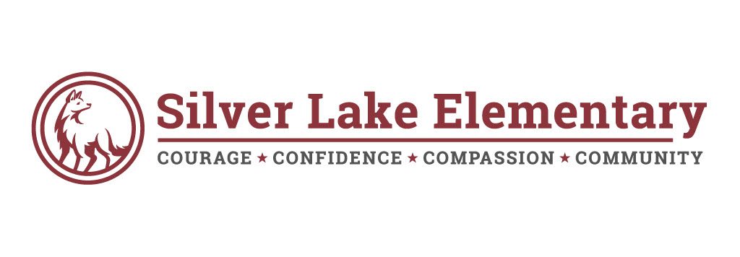

**School Community Council**

**3 September 2020**

**Agenda**

1. Pledge of Allegiance
2. Introductions
3. Chair, Vice Chair and Secretary Selection
4. Video Training
5. SL Trustlands Budget
6. School Improvement Plan
7. Meeting Dates

